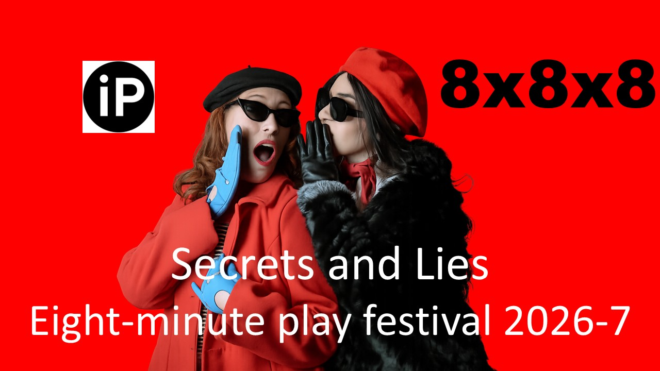

Image by Gabii Fernandez

- Eight different playwrights
- Eight exciting pieces of new theatre
- Eight minutes each

In 2026-7 Ilkley Playhouse will host a playwriting festival to offer writers the chance to put their original, previously unpublished short work on stage. The festival will take place in our Wildman (studio) theatre. That’s right: your new play will be performed by skilled actors in a professional studio theatre with full lights and sound for three or four nights in September 2027.

The theme for 2026 is Secrets and Lies

The top sixteen plays will be published in book and kindle form on Amazon. You may like to purchase one or more of these books to see the winners from previous festivals. https://www.amazon.co.uk/s?k=jay+cundell+walker&crid=3PDK33K5VJDIL&sprefix=jay+cundell+walker%2Caps%2C149&ref=nb_sb_noss

Want to know more, then see those T&Cs……
Terms and conditions

Entries will be accepted from 1st September to 1st November 2026.

You can enter only once. Comedic entries are especially welcomed, as the bulk of our entries in the past have been excellent dramas. Because these plays are fully produced for four evenings at Ilkley Playhouse, we are seeking a balanced programme of comedy and drama; maybe even a thriller.

Entries must be anonymous and previously unperformed in any venue. Please write something special for Secrets and Lies.

By entering you give us the right to perform your piece four times free of royalties and to use performance and rehearsal images for ongoing publicity purposes.

Your scripts must be submitted without any author’s name on them. The play title should appear on each page as a header and pages should be numbered as a footer. There is a maximum of three actors per play.

Scripts should be submitted as a Word document and saved as the title of the script. Please don’t call your script ‘Secrets and Lies’ as that could cause some confusion!

This year we are requesting a prescribed format, to aid the compilation of the book containing the sixteen finalists. This is attached as pages 4 and 5.

Submissions are to 8x8x8festival@gmail.com

The title of the email should be the title of your play. As well as your play, don’t forget to attach the application form which is on the next page.

The judges’ decision is final and successful writers will be informed before the end of January 2027. Winning playwrights attending the show will be asked if they might like to take part in a Q&A session after the performances are complete.

GET YOUR ENTRIES IN EARLY AS WE WILL STOP ACCEPTING SUBMISSIONS ONCE WE REACH 100. WEEKLY UPDATES OF NUMBERS WILL APPEAR ON OUR FACEBOOK PAGE FROM 1ST SEPTEMBER.
https://www.facebook.com/groups/593569814696155

Application Form 2026-7

Name
Address

Phone
E mail

What is the title of your play?

How did you hear about the IP Writing Festival?

I confirm I have read and understand the terms and conditions

Signature (may typed): Date:

Remember to send this form AND your script.
- no name to appear anywhere on your play which should be saved in word or pdf
- title of email will be 8x8x8 +’ title of play’
- no content in the email
- your play is sent as an attachment which is saved as ‘title of play’
- Each page of your play has the title as a header and page numbers as the footer.
- e mail to 8x8x8festival@gmail.com

ONLY ONE ENTRY PER PLAYWRIGHT PLEASE.

TITLE OF PLAY

CHARACTERS:
Ann, in her 30s
Ben, in his 40s
Col, any age
Lights up on ANN and BEN at a conference table. There are piles of papers in front of them. COL enters, carrying a bagel.

ANN (Picks up a sheaf.) Wow, is that the title of the play I see up there in the header?
BEN Yup. And page numbers over there on the bottom left, too. Handy.
ANN Yeah, handy. The judges know right away if somebody is over seven pages. Which is good, right? To know, I mean?
BEN Well, yeah. It should be a max of seven pages, less for a monologue. Because timewise—
COL (Looking over Ann’s shoulder.) Excuse me… I don’t mean to interrupt, but… I just wondered… Is that font Ariel?
ANN Uh huh. Ariel 12, I’m pretty sure. It’s supposed to be the easiest for everyone to read, whatever your ability.
COL Awesome. (COL looks around, finds a spot, and carefully sets down his bagel. Then he picks up another sheaf of paper.) This one is awesome. What margins, do you think? (Shows BEN the play he’s holding.)
BEN Well, looks like 2.5cm left, top and bottom and 2cm on the right. You find that in layout, margins, custom margins when you’re using Word.
ANN Right, right. Good to know.
COL This one… The character names are in caps and bold, helps them to stand out. everything is 1.5 spaced, and stage directions are indented at least six centimetres. Oh, and the stage directions are italicized, too. I love this play!
BEN But aren’t they just being picky? Why would they ask the playwrights to do this?
ANN Well, a few reasons. It helps the judges, so potentially they can read more scripts and give each script more attention, because they don’t have to time them all.
COL I see.
ANN But primarily, it makes it so much easier to get all the winning sixteen plays into a book which will then be on sale at the festival for the audience to buy. That’s why they need to be in Word. Imagine, your winning play in a real book for anyone to buy on Amazon. They can check out the previous books here:
https://www.amazon.co.uk/s?k=jay+cundell+walker&crid=357FZYR68T5Q5&sprefix=jay+cundell%2Caps%2C87&ref=nb_sb_ss_ts-doa-p_1_11
BEN suddenly leaps up from his chair,
knocking a flurry of paper to the floor in his haste.
ANN What is wrong with you?
BEN That-that… That script! The last one I picked up. It’s 17 pages long! It’s in some weird teeny-tiny font I can’t read! And I think the margins are about a quarter of an inch! What was the playwright thinking?
ANN (Shaking her head sadly.) Do they really think we won’t notice?
COL But… What if the play is really good, just hiding inside some terribly formatted exterior?
ANN I guess we’ll never know.
ANN rises from the table as BEN tears the badly formatted play in half. All three gaze at each other as the lights go down.
BLACKOUT.

