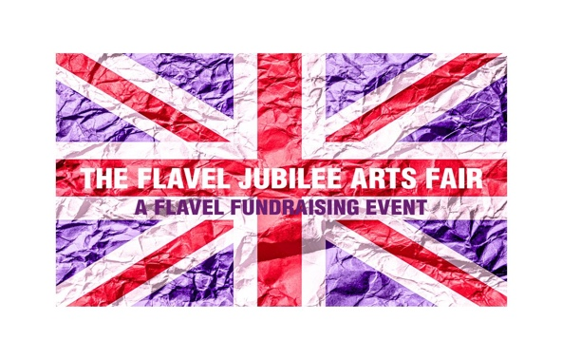

The Flavel Jubilee Arts Fair June 2nd & 3rd 10.00 – 16.00
Information Sheet for Contributors
This is a wonderful opportunity to display and sell your work over the Jubilee Celebration Weekend, when there should be plenty of visitors in Dartmouth!
We aim to make this event as broad as possible, so come along and set up a stand or display your work in the gallery; we would welcome paintings, photography, sculptures, craft work, writing, mixed media pieces, ceramics and more.
Pitches in the auditorium will include a table that contributors will be able to dress in their own style to display their work.
The Gallery area will be wall space only, and individual/multiple spaces can be hired for the week beginning 30th May.
It will be the contributor’s responsibility to deal with any money transactions for the sale of their work.
Contributors will be responsible for their own stands during the Fair.

Costs:
A pitch in the auditorium area including a table for one day - £40
A pitch in the auditorium area including a table for two days - £60
Gallery will be wall space only and will be for a week beginning 30th May:
For a gallery space of 1.5 m - £20
For a gallery space of 1.5 m - £15
Bookings must be made in advance, and payments must be received by 26th May at the latest.

Please contact Lindsay Ellwood to book a space or for more information: lindsay.ellwood@btinternet.com

