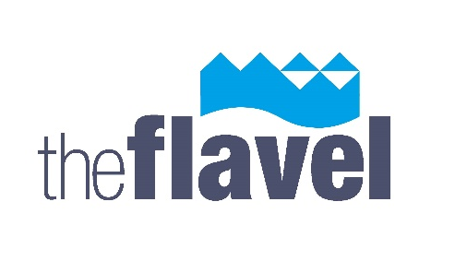
APPLICATION FORM
for submitting work(s) for
The David Alexander 2026 Open Art Exhibition
‘HOME’
Monday 2 November – Saturday 28 November 2026
Please make sure that you fill in the form completely and bring it with the work for consideration on between 9am and 11am on Monday 2 November 2026. You are responsible for unpacking your art and taking the packing material away with you.
Please adhere your name and title of the work to the back of each piece.
Please read the separate information sheet carefully.
Please contact michael@theflavel.org.uk with any queries.
Name:
House name or number:
Street Name:
Village:
Town:
Postcode:
Telephone no:
Mobile No:
Email address:

Please tick if you DO NOT wish your details to be added to the Flavel’s database. _____
We will not pass on your details to any other organisation or company.

I would like to submit for consideration the following work(s)
(maximum two works per artist, £5 per piece of work submitted)

Title | Medium | Size (framed) | Sale Price

Please note that the Flavel will retain 25% of the sale price plus VAT for any items
sold to cover the costs of administration and other sales charges.

Please see separate document for further information.

