Flavel Forever Testimonials
V1.0 27/2/25 Andrew Dalton
The following testimonials can be used in email and social media publicity with some exceptions – see below.
Name | Photo | Testimonial
DBB | Not available | In the 25 years following the opening of the Flavel, it has developed into a wonderful cultural centre of arts, music, entertainment, a busy library and much more. It feeds my own love of Classical Music and related activities. Also, with the provision of a base for organisations like U3A, there’s no excuse for being bored in Dartmouth. Many thanks to all the staff and the great army of volunteers who keep it running.
Richard Hull | Not available | Not available
Anon |  | I support the Flavel because I can't think of a more deserving cause which will maintain the cultural and artistic life of the local area for the benefit of all - residents and visitors of every age.  A previous generation founded and got the Flavel built with the simple aim of enriching our lives - the least that I can do is contribute my bit to ensure that this wonderful asset survives into the future for the benefit of all.
Diana Crook | 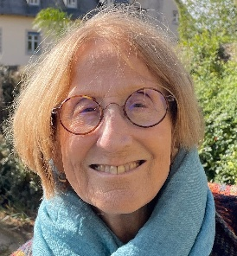 | For me, The Flavel is a jewel set in the heart of Dartmouth. Whether you are going on your own or are part of a group, there is always a warm welcome and great shows to match all tastes. For me, the live screenings from the Royal Opera and Ballet tempt me in, every time. I’m soon in the heat of Seville with Carmen or dancing with the Sugar Plum Fairy. Or I’m in the best seat at the National Theatre, seeing a one-man show, or at the latest Hollywood blockbuster. With no Arts Council funding, the Flavel can only continue if we support it financially, or by coming, making friends, and enjoying first class entertainment or the use of meeting rooms. There is also a great Café!
Mike Trevorrow | 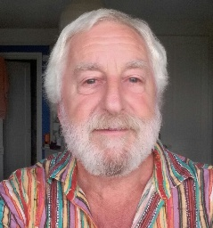 | The Flavel is firmly established as the cultural centre of Dartmouth and Kingswear, that’s where we go for fun and enlightenment. Bless its boots and those who work there.
Lindsay Charlesworth | 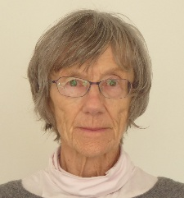 | I have loved and supported the Flavel ever since we arrived here in 1995 when it was just a dream consisting of the Flavel Church Hall and the old fire station. Now we have this wonderful centre combining the library with the Flavel and all its varied events, activities, and volunteering opportunities. A priceless asset on so many levels which we mustn’t lose.
Anon |  | I am supporting The Flavel as I believe it is an integral part of my Dartmouth life. I am able to volunteer, attend events by myself and always feel welcomed and part of the community.  In my opinion Dartmouth would be lost without it.
Tony Hulatt | 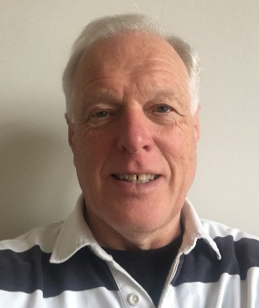 | The wider Dartmouth community has been so fortunate to enjoy the incredible range of benefits that the Flavel Arts & Community Centre has delivered during its first 20 years. However, it is vital that the future of this community hub is maintained for the next generation of users and that is why I am supporting the Flavel Forever Project to ensure that the funding is in place to maintain, develop, and maximise the Centre’s facilities to enable everyone to continue to enjoy this unique space.
JG | Not available | My wife and I support Flavel Forever as the Flavel is part of the lifeblood of Dartmouth and a much wider area providing a good variety of entertainment including films, live music, talks, live-streamed plays, concerts, ballets; quiz nights, art exhibitions, rooms for clubs and societies to use, or for Pilates etc.  It is a very welcoming place with friendly staff and has its own popular café, a kitchen for tea/coffee for certain occasions and a bar open during the main events.  The show must go on!
Keith Williams | Not available | Congratulations to the founding members who have sponsored the important “Flavel Forever” initiative. Dartmouth without the Flavel would be a lesser place to live and I wish all the team ever succuss in delivering the turnaround that everybody recognises is vital
Paula Cooper | 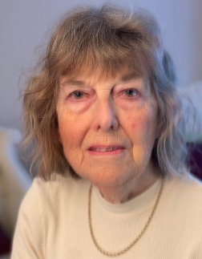 | I have been a supporter and Volunteer at the Flavel since the idea of a Cultural Centre was first proposed over 20 years ago. Then, as now, the Town requires a Centre offering enjoyment for all in the form of films, broadcasting of shows from London, live music, children and adult workshops etc.  The Flavel really does have something for everyone, so your ongoing support is vital.
Paul & Mary Fenwick | 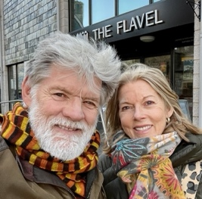 | The Flavel is a precious venue - a Dartmouth hub for music, live performance, cinema, and art - and we want to support, encourage and appreciate it as much as we can.

